 | 1.What problem are you wanting to solve? Or what benefit do you want?
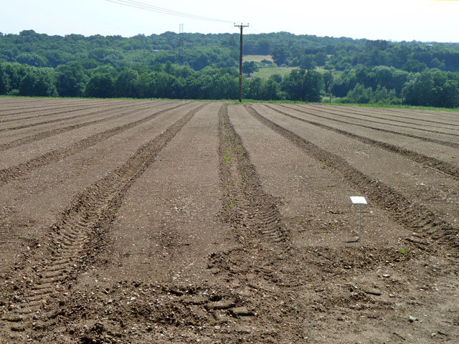 | 2.Where will you plant it?
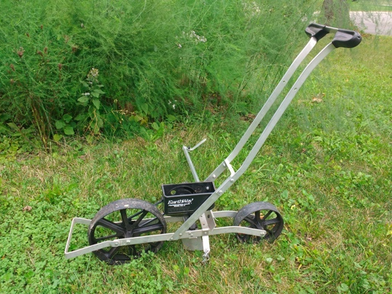 | 3. How will you seed it? Do you have needed equipment and labor?
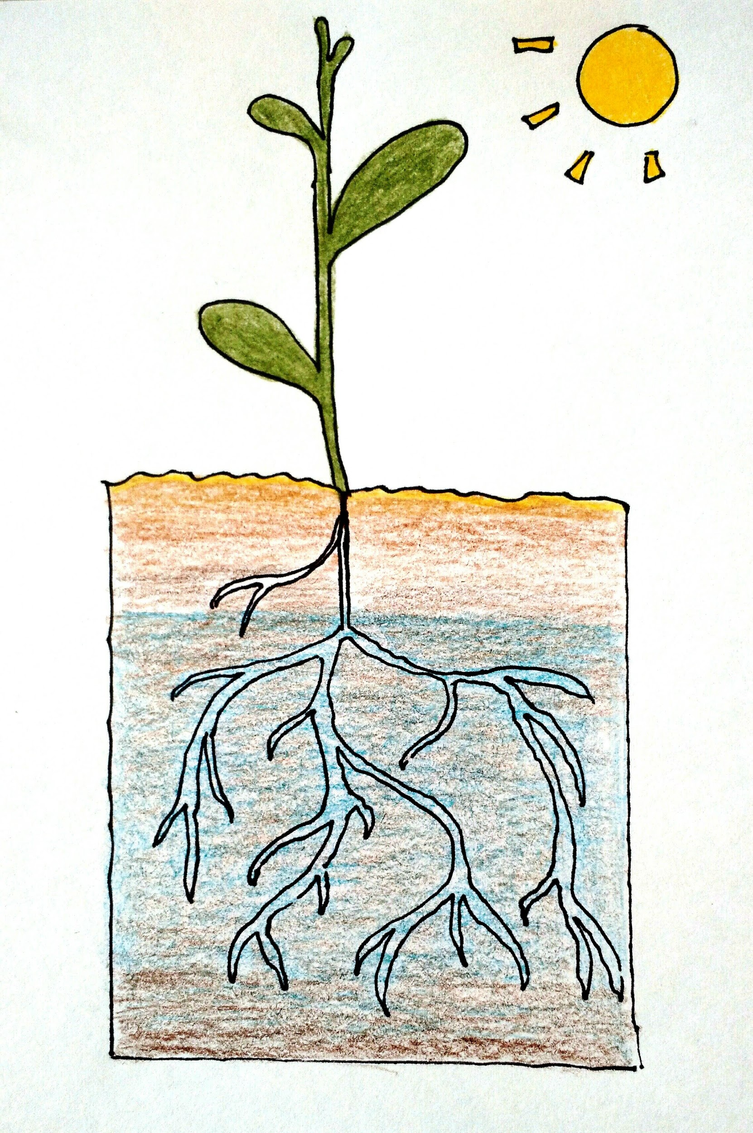 | 4. What will the weather be like? What will soil temperature and moisture conditions be like? Will you have time to make this work?
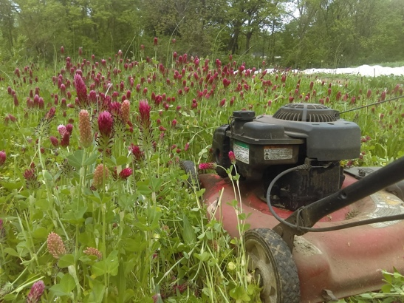 | 5. Will it winterkill? Or how do you kill it and plant into it?

