1 Gallon = | 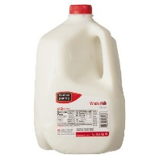
1 Cup = | 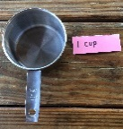
½
Cup =
Pound = | 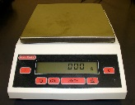
Pesticide
KEY

Kaolin Clay-
Surround WP

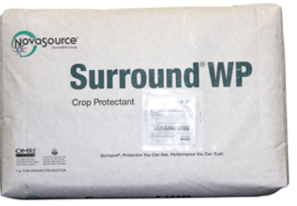

**Note: Sq. foot conversion to number of beds in the table below is approximate. The range of how much Kaolin to apply per sq. foot is wide and therefore extreme accuracy in space application isn’t crucial.**
Bed Size  150 sq ft  or  one 50 foot bed | Bed Size  300 sq feet  or  one 100 foot bed | Bed Size  650 sq feet or  two 100 foot beds | Bed Size  1,000 sq feet  or  three 100 foot beds | Bed Size  1,300sq ft  or  four 100 foot beds
½ gallon  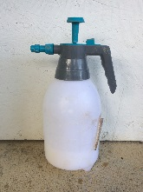 | 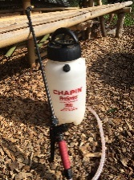  1 gallon | 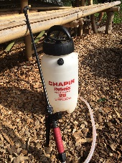  2 gallons | 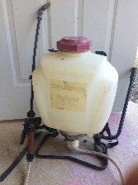  3 gallons | 4 gallons
¼ pound OR  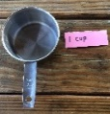  1 and ½ cups | ½ pound OR  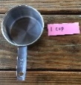  3 cups | 1 pound OR  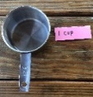  6 cups | 1 ½ pounds OR 9 cups | 2 pounds OR  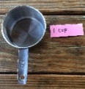  12 cups
Add  Water  ½ gallon | Add  Water  1 gallon | Add  Water  2 gallons | Add  Water  3 gallons | Add  Water  4 gallons
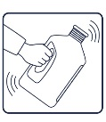  Mix | Mix | Mix | Mix | Mix

Directions:

Surround WP
Kaolin Clay

- Wear mask while mixing
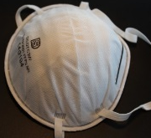

- Mix in bucket first. Then put in sprayer. Shake often while using!!
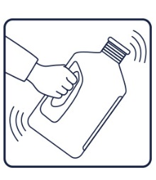
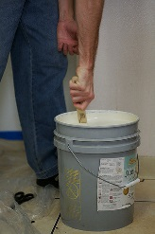

- Add the powder slowly to approximately 1/4 of the water you will be using, stir and mix well by shaking vigorously for 30 seconds.
- Add the remaining ¾ of the water and shake for an additional 30 seconds.
- When finished, spray until the container is empty and flush the sprayer system hoses by running clean water through. Leftover mix can be stored at room temperature. Use within 2 weeks to avoid spoilage. Rinse the sprayer thoroughly when finished and again before mixing or spraying the next batch.
Kaolin Clay – Surround WP

Information
- Derived from Kaolin clay, a natural mineral. Forms a barrier that acts to control insect pests and disease.
- Tiny particles of the kaolin clay powder attach to insects when they contact it, agitating and repelling them. Even if the particles do NOT attach to their bodies, the insects find the coated plant/ fruit unsuitable for feeding and egg-laying.

- Protects against sunburn and heat stress.
- Protective white film cools plants by up to 15°F, which can help to reduce heat and water stress.

Pests and Heat Stress
Cucumber beetles, Potato Beatle, Cut Worms, Grasshoppers, Gypsy Moths, Japanese Beetles, Leaf Roller, Leafhoppers, Stink Bugs, Thrips
- Effective for pests with antennas – clay gets stuck in antennas and disorients
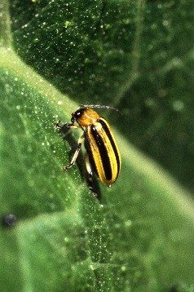
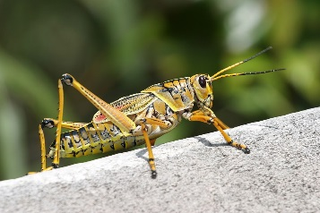
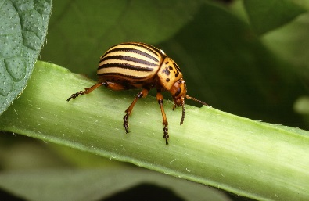
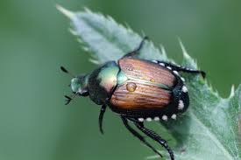

Where to Buy
Country Farm and Home
101 S Small Street, Pittsboro, NC 27312

Fifth Season
106 S Greensboro St Ste D, Carrboro, NC 27510

Internet

Cost
5 lb: $28.00
25 lb: $40.00 - $57.00

