Weekly Calendar WEEK 9 February/March 2016
February  28  Sunday | 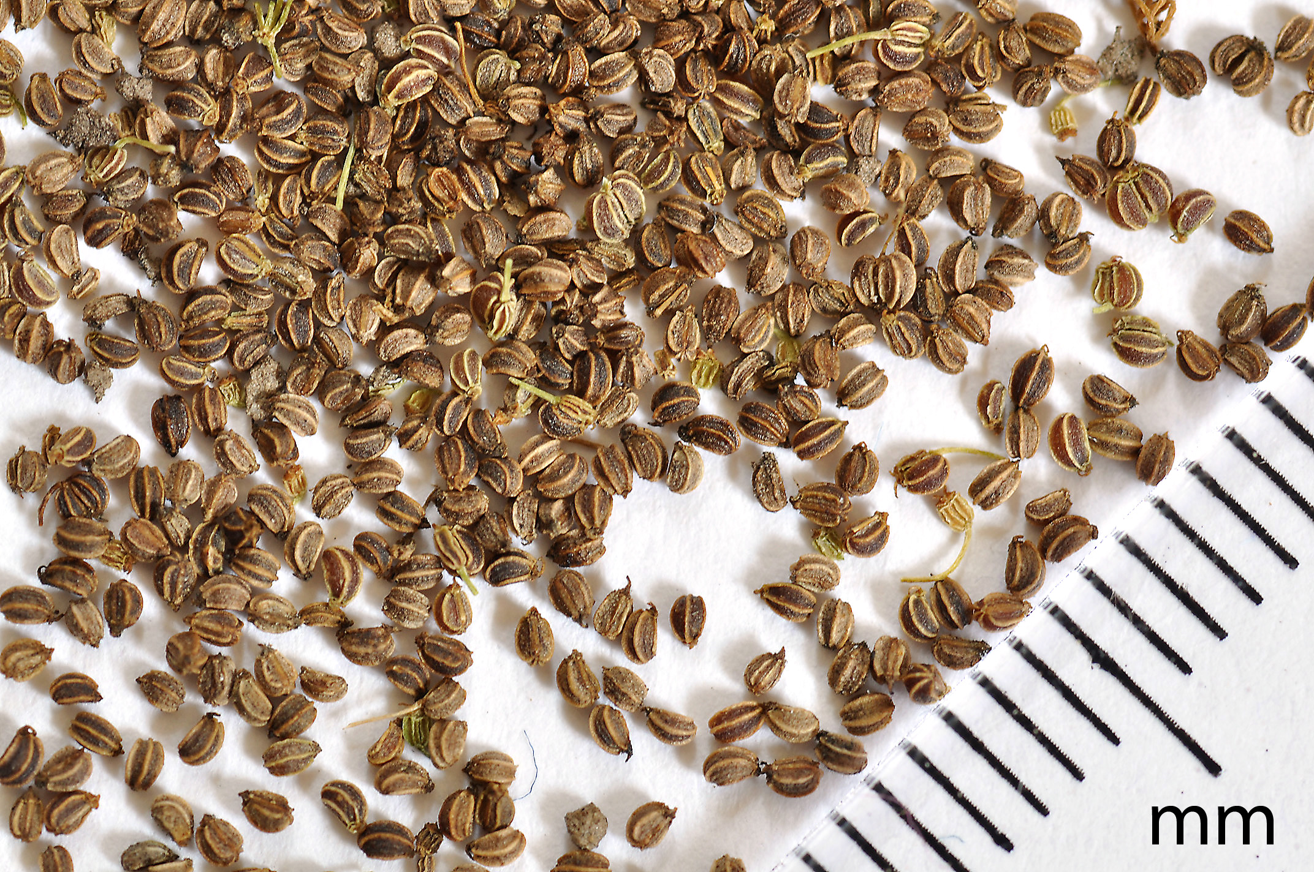 | 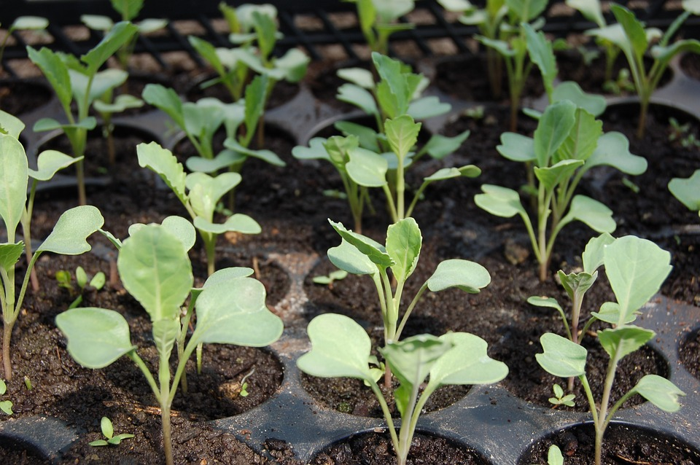
February
29
Monday
March  2  Wednesday | Use Row Cover  TWO HOOPHOUSES: (7.5 ROW FEET per CSA in each hoophouse—5 rows per bed. 7.5 ROW FEET for carrots and 7.5 ROW FEET for beets—15 row feet total per CSA box)  TWO HOOPHOUSES:  Carrots 1 Nelson  Carrots 1 Sugarsnax  Beets 1 Red Ace  Beets 1 Touchstone  Turnip 1: Hakurei  Radishes 1: Bravo  Radishes 1: Rudolf  Spinach 1: Space  Sugar Snaps Peas 1: Sugar Snap
March
3
Thursday
March
4
Friday
March
5
Saturday
Weekly Calendar WEEK 10 March 2016
March
6
Sunday
March
7
Monday
March
9
Wednesday
March
10
Thursday
March  11  Friday | Radish 2: Easter Egg  Asian Greens 1: Mizuna Red Streaks | Onions 1: Red River  Onions 1: Candy  Onions 1: Superstar  Onions 1: Tropea  Cilantro 1: Santo  Asian Greens 1: Tatsoi  Broccoli 1: Green Magic  Broccoli 1: Imperial  Broccoli 1: Gypsy  Cabbage 1: Rubicon  Cabbage 2: Red Express  Cabbage 3: Tendersweet  Swiss Chard 1: Bright Lights  Collards 1: Flash  Fennel 1: Orion  Kale 1: Toscano  Kale 1: Red Russian  Cauliflower 1: Bishop  Cauliflower 1: Snow Crown  Parsley: Giant of Italy  Leeks 1: Pandora  SOME (NOT ALL) BANNER STARTS: HOLD & JUICE LETTUCE AND RED CHOY: STEP UP TOMATOES
Weekly Calendar WEEK 11 March 2016
March
13
Sunday
March
14
Monday
March  16  Wednesday | Sorrel 1  Sugar Snap Peas 2 Sugar Snap  Carrots 2 Nelson  Carrots 2 Sugarsnax
March
17
Thursday
March  18  Friday | Radish 3 Shunkyo  Radish 3 Bravo  Turnip 2 Hakurei  Salad Mix 1 Red Saiad Bowl  Salad Mix 1 Simpson  Salad Mix 1 Arugula | REMAINING BANNER STARTS:  Lettuce 1: Red Sails  Lettuce 1: Crispino  Lettuce 1: Nancy  Asian Greens 2: Red Choy  HOOPHOUSE  Tomato 1: Sun Gold  Tomato 1: Early Girl
March
19
Saturday
Weekly Calendar WEEK 12 March 2016
March
20
Sunday
March  21  Monday | Spinach 2: Space
March
22
Tuesday
March
23
Wednesday
March
24
Thursday
March  25  Friday | Sugar Snap Peas 3 Sugar Snap
March
26
Saturday
Weekly Calendar WEEK 13 March/April 2016
March
27
Sunday
March
28
Monday
March
29
Tuesday
March  30  Wednesday | Salad Mix 2 Red Saiad Bowl  Salad Mix 2 Simpson  Salad Mix 2 Arugula
March
31
Thursday
April  1  Friday | Radish 4: Daikon Alpine  Radish 4: Davignon  Cilantro 2: Santo  Turnip 3: Hakurei | Lettuce 2 Cherokee  Lettuce 2 Mottistone  Nasturtium 1 Jewel Mix  Asian Greens 3 Zamboni  Asian Greens 3 Senposai
April
2
Saturday
Weekly Calendar WEEK 14 April 2016
April
3
Sunday
April
4
Monday
April
5
Tuesday
April  6  Wednesday |  | Beets 2 Touchstone Gold  Beets 2 Red Ace
April
7
Thursday
April
8
Friday
April
9
Saturday
Weekly Calendar WEEK 15 April 2016
April
10
Sunday
April  11  Monday | Radish 5: Easter Egg
April
12
Tuesday
April  13  Wednesday | Turnip 4: Hakurei  Cilantro 3: Santo
April
14
Thursday
April
15
Friday
April
16
Saturday
Weekly Calendar WEEK 16 April 2016
April
17
Sunday
April
18
Monday
April
19
Tuesday
April  20  Wednesday | Radish 6: Shunkyo  Radish 6: Bravo | Summer Squash 1: Bennings  Summer Squash 1: Zephyr  Summer Squash 1: Safari  Summer Squash 1: Alexandria
April
21
Thursday
April  22  Friday |  | Tomato 2: Sun Gold  Tomato 2: Celebrity  Tomato 2: Bolseno  Tomato 2: Striped German  Tomato 2: Pink Tiger and Blush  Tomato 2: Cherokee Purple  Tomato 2: German Johnson  Tomato 2: Purple Bumblebee and Sunrise
April
23
Saturday
Weekly Calendar WEEK 17 April 2016
April
24
Sunday
April  27  Wednesday |  | Cucumbers 1: Suyo Long  Cucumbers 1: General Lee  Cucumbers 1: Paw Moo Big Sweet  Cucumbers 1: Wei, Paw Moo, Krit Htoo  Pumpkins 1: Bungkan  Pumpkins 1: Thai Muang  Pumpkins 1: Metro  Pumpkins 1: Bungkan  Pumpkins 1: Sunday Sweet
April
28
Thursday
April  29  Friday | Salad Mix 3: Red Salad Bowl  Salad Mix 3: Simpson  Salad Mix 3: Arugula  Edamame 1: Butterbeans  Okra 1: Red Burgundy  Okra 1: Clemson Spineless | Basils 1: Thai Cooking  Basils 1: Tulsi  Basils 1: Lemon  Basils 1: Thai Sweet  Basils 1: Genovese
April
30
Saturday
Weekly Calendar WEEK 18 May 2016
May
1
Sunday
May  2  Monday | Green Beans 1: Tongue of Fire  Green Beans 1: Provider  Green Beans 1: Carson
May
3
Tuesday
May  4  Wednesday | Long Beans 1: Red  Long Beans 1: Green | Asian Herbs 1 Roselle  Asian Herbs 1 Water Spinach  Asian Herbs 1 Na Ga Wa  Melons 1: Sugar Baby  Melons 1: Little Baby Flowers  Melons 1: Hale’s Best Cantaloupe
May
5
Thursday
May  6  Friday |  | Gourds 1: Wax Small Round  Gourds 1: Winged Bean  Gourds 1: Green Skin  Gourds 1: Nam Tao Klum  Gourds 1: Bonanza  Gourds 1: Tri Sa’s Seed  Gourds 1: Mara  Gourds 1: Snake Gourd Krit Htoo
May
7
Saturday
Weekly Calendar WEEK 19 May 2016
May
8
Sunday
May
9
Monday
May  11  Wednesday | SUMMER CSA BEGINS  Salad Mix 4: Red Salad Bowl  Salad Mix 4: Simpson  Salad Mix 4: Arugula | Summer Squash 2: Safari  Summer Squash 2: Bennings  Summer Squash 2: Zephyr  Summer Squash 2: Alexandria  Peppers 1: Banana  Peppers 1: Carmen  Peppers 1: Aji Dulce  Peppers 1: Lunchbox  Peppers 1: Nardello
May
12
Thursday
May  13  Friday |  | Eggplant 1 Black King  Eggplant 1 New Leader  Eggplant 1 Orient Charm  Eggplant 1 Orient Express  Eggplant 1 Thai Round  Eggplant 1 Violet Prince  Eggplant 1 Little White  Eggplant 1 Wei’s Purple Round  Sweet Potatoes 1
May  14  Saturday |  | 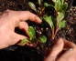
Weekly Calendar WEEK 20 May 2016
May
15
Sunday
May
16
Monday
May  18  Wednesday | Radish 7: D’Avignon
May
19
Thursday
May  20  Friday |  | Tomato 3: Sun Gold  Tomato 3: Celebrity  Tomato 3: Bolseno  Tomato 3: Striped German  Tomato 3: Pink Tiger and Blush  Tomato 3: Cherokee Purple  Tomato 3: German Johnson  Tomato 3: Purple Bumblebee and Sunrise  Pumpkins 2: Bungkan  Pumpkins 2: Thai Muang  Pumpkins 2: Metro  Pumpkins 2: Bungkan  Pumpkins 2: Sunday Sweet
May
21
Saturday

Weekly Calendar WEEK 21 May 2016
May
22
Sunday
May
23
Monday
May
24
Tuesday
May  25  Wednesday | Green Beans 2: Tongue of Fire  Green Beans 2: Provider  Green Beans 2: Carson
May
26
Thursday
May  27  Friday |  | Basils 2: Lemon  Basils 2: Thai Sweet  Basils 2: Genovese
May
28
Saturday
Weekly Calendar WEEK 22 May/June 2016
May
29
Sunday
May
30
Monday
May
31
Tuesday
June  1  Wednesday | Edamame 2: Butterbeans
June  3  Friday | Long Beans 2: Red  Long Beans 2: Green | Cucumbers 2: Suyo Long  Cucumbers 2: General Lee  Cucumbers 2: Hybrid Champ  Cucumbers 2: Hybrid Champ
June
4
Saturday
Weekly Calendar WEEK 23 June 2016
June
5
Sunday
June
6
Monday
June
7
Tuesday
June  8  Wednesday |  | Peppers 2: Banana  Peppers 2: Carmen  Peppers 2: Mellowstar  Peppers 2: Lunchbox  Peppers 2: Nardello  Asian Herbs 2 Water Spinach  Asian Herbs 2 Na Ga Wa
June
9
Thursday
June  10  Friday |  | Gourds 2: Tri Sa’s Seed  Gourds 2: Snake Gourd Krit Htoo  Gourds 2: Bonanza  Gourds 2: Green Skin  Gourds 2: Nam Tao Klom
June
11
Saturday
Weekly Calendar WEEK 24 June 2016
June
12
Sunday
June
13
Monday
June
14
Tuesday
June
15
Wednesday
June
16
Thursday
June  17  Friday | Okra 2: Red Burgundy  Okra 2: Clemson Spineless | Tomatoes 4: Celebrity  Tomatoes 4: Sun Gold
June
18
Saturday
Weekly Calendar WEEK 25 June 2016
June
19
Sunday
June
20
Monday
June
21
Tuesday
June
22
Wednesday
June
23
Thursday
June
24
Friday
June
25
Saturday
Weekly Calendar WEEK 26 June/July 2016
June
26
Sunday
June
27
Monday
June
28
Tuesday
June  29  Wednesday |  | Basils 3: Genovese  Basils 3: Thai Sweet  Basils 3: Tulsi
June
30
Thursday
July  1  Friday | Spring CSA Ends  Long Beans 3: Red  Long Beans 3: Green | Tomatoes 5: Celebrity  Tomatoes 5: Sun Gold  Cucumbers 3: Suyo Long  Cucumbers 3: Diva
July
2
Saturday
Weekly Calendar WEEK 27 July 2016
July
3
Sunday
July  4  Monday | Make-up Week
July
5
Tuesday
July  6  Wednesday | Green Beans 3: Tongue of Fire  Green Beans 3: Provider  Green Beans 3: Carson  Okra 3: Red Burgundy  Okra 3: Clemson Spineless | Eggplant 2 Orient Charm  Eggplant 2 Black King  Eggplant 2 New Leader  Eggplant 2 Orient Express  Eggplant 2 Thai Round  Eggplant 2 Violet Prince  Eggplant 2 Little White  Eggplant 2 Wei’s Purple Round  Peppers 3: Banana  Peppers 3: Carmen  Peppers 3: Mellowstar  Peppers 3: Lunchbox  Peppers 3: Nardello  Basils 4: Genovese  Basils 4: Thai Sweet
July
7
Thursday
July
8
Friday
July
9
Saturday

