APPENDIX - New Entry Sustainable Farming Project

EXAMPLE 1: Farm Business Planning Curriculum - Proposed Course Syllabus
The New Entry Sustainable Farming Project is proposing to revise its annual Farm Business Planning Course (last revised in 2005) by providing pre-production enterprise courses to aspiring and beginning farmers. Following an introductory Explore Farming! course, beginning farmers will select a production-based course, either (or both) crop production (specialty vegetables), and/or livestock production to be held in fall/winter either in the classroom or online. Farmers will then be prepared with specific enterprise knowledge to participate in a basic/introductory farm business planning course and complete a start-up farm business plan. Following development of a farm business plan, new farmers can elect to participate in hands-on, practical skills trainings in crop production and livestock through a series of “field schools” held during the growing season. In subsequent years, with increasing entrepreneurship experience, financial records, and enterprise analysis, beginning farmers can participate in a series of Advanced Farm Business topics to hone and refine their business plans and assess profitability, management goals, and issues of scale. Ongoing individual technical assistance will supplement classroom and practical skills knowledge. Connections to statewide and regional networks of beginning farmer service providers will complement classroom and hands-on learning.
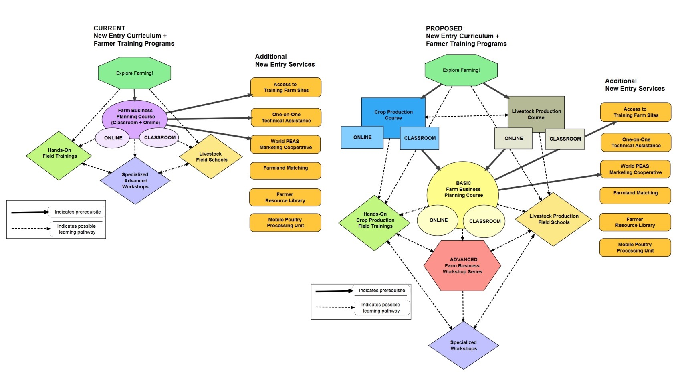Crop Production Course (New) – Fall, Oct - Dec (Classroom and Online)
Description: This course will teach students the fundamentals of crop production on a small farm, covering everything from soil fertility to crop planning. The course focuses on annual vegetable production but also includes flower, herb and perennial crops. It provides a classroom foundation that is intended to complement hands-on field-based workshops that are offered throughout the growing season. It also builds a student’s context of production knowledge that is essential for success in the Basic Farm Business Planning Course offered in the winter.

Format: This course is offered in a classroom format at the New Entry office/teaching space in Lowell or online. Both formats feature informal and interactive learning environments, with an emphasis on real-life examples, case studies, guest farmers, Q +A, and dynamic activities.
Timeframe: This course meets once a week in the evenings for 9 weeks. It is offered once a year in the fall, from October – December.
Prerequisite: Explore Farming! course offered by New Entry. Some experience in the field is highly recommended.
Course Themes: Documenting biological time and labor, tracking and organizing costs, and determining appropriate scale.

Crop Production Lesson Topics:
- The Nature of Soils
  - Interpreting soil test reports
  - Nutrient management of vegetables with organic soil amendments
  - Using scale appropriate implements and tools to establish ideal cropping environments for both cash crops and fallows
- The Benefits of Cover Crops
  - Biological nutrient management
  - Crop rotations
  - Utilizing cover crops to reduce weed, insect, & disease press
- Crop Cultures
  - Utilizing plant families to determine ideal conditions for individual cash crops
  - Learning how to plan your seed orders
- Common Weeds, Insect Pests & Diseases on Mixed Vegetable Farms
  - The cultural and biological management of weeds
  - The cultural and biological management of insect pests and diseases
  - Creating habitat to host beneficials
- The Safe and Effective Use of Organic Pesticides
  - Understanding the regulation of pesticides and certified organic standards
  - When and how to safely apply organic pesticides
- Postharvest Techniques for Handling both Fresh Vegetables and Winter Storage Crops
  - Protecting the shelf-life and quality of fresh produce during the harvest and packing cycle
  - Food Safety Basics
  - GAP Audits
- Season Extension
  - Designing for structural integrity and energy efficiency
  - Season extension options: Greenhouses, high tunnels, and row covers
- Exploring Machines and Tools
  - Purchasing farm equipment and tools
  - Scheduling maintenance and practicing safety
  - Exploring the new world of Farm Hacks and technology innovation
- Crop Planning for A Micro-Farm
  - Farm planning tools & technology options
  - New Entry’s incubator farms and World PEAS logistics
  - Current guest incubator farmers share their strengths and challenges

Livestock Production Course (New) – Fall, Oct - Dec (Classroom and Online)
Description: This course will teach students the fundamentals of livestock production on a small farm, covering everything from pasture management to regulations. It provides a classroom foundation that is intended to compliment hands-on, enterprise specific, livestock field school workshops that are offered throughout the growing season. It also builds a student’s context of production knowledge that is essential for success in the Basic Farm Business Planning Course offered in the winter.
Format: This course is offered in a classroom format at the New Entry office/teaching space in Lowell or online. Both formats feature informal and interactive learning environments, with an emphasis on real-life examples, case studies, guest farmers, Q +A, and dynamic activities.
Timeframe: This course meets once a week in the evenings for 7 weeks. It is offered once a year in the fall, from October – December.
Prerequisite: Explore Farming! course offered by New Entry. Some experience with animals in the field is highly recommended.
Course Themes: Niche marketing, tracking and limiting costs, and scaling up.

Livestock Production Lesson Topics:
- Comparing Animal Enterprises
  - The benefits and challenges of different livestock enterprises
  - Production scheduling throughout the seasons
- Assessing and Sourcing Livestock Inputs
  - Feed, infrastructure, time management and more
- Processing, “Post-Harvest Handling”, and Regulations
  - Processing Options and Regulations
    - Red meat, poultry, eggs, dairy, fiber
  - Product handling and storage
    - Meat, eggs, dairy, fiber
- Marketing Livestock Products
  - Marketing options (meat, eggs, dairy, fiber)
    - Direct sales, pre-orders, on-farm sales, farmers markets, etc.
    - Scaling up – restaurants, other farmstands, CSAs, wholesale, auction, etc.
    - Animal sales – feeders, breeding stock, 4-H
    - Other enterprise specific options (e.g. fiber – wool pools, dairy – cheese and yogurt)
  - Niche markets, marketable attributes, and pricing
- Sourcing Animals, Animal Health, and Bio-security
  - How to find and maintain healthy animals
  - Basic on farm animal health practices and when to call a veterinarian
  - How to safeguard your livestock through appropriate biosecurity practices
- Overview of Grazing and Pasture Management
  - Ruminants vs. non-ruminants
  - Grazing systems overview
  - Pasture management principles
  - Swine and poultry pasture management and multi-species grazing
- Basic Livestock Recordkeeping
  - Best practices for recordkeeping in the field

Basic Farm Business Planning (Revised) - Winter, Jan – Mar (Class and Online)
Description: This course will teach students the fundamentals of planning a farm business. The main goal of this course is to ensure that students go forward with the knowledge and skill set to maintain the long-term financial sustainability of their farm business. This course will help students understand and appreciate the value of learning and applying the basics of financial literacy and bookkeeping, reinforce a financial management mindset, and provide students with financial management tools and the skills to utilize those tools when the class is over. Students will weave their personal farm goals, enterprise selection, market research, and strengths and resources into a cohesive and complete farm business plan.
Format: This course is offered in a classroom format at the New Entry office/teaching space in Lowell or online. Both formats feature informal and interactive learning environments, with an emphasis on real-life examples, case studies, guest farmers, Q +A, and dynamic activities.
Timeframe: This course meets once a week in the evenings for 9 weeks. It is offered once a year in the winter, from January – March.
Prerequisite: Crop Production Course and/or Livestock Production Course offered by New Entry. Some experience in the field is highly recommended.

Basic Farm Business Planning Lesson Topics:
- Visioning, Goal Setting, and Measuring Success
- Holistic financial planning – how to shape your goals and decisions around values and resources
- Outline of farm mission, vision, goals
- Introduction to Marketing
  - Marketing and sales basics
  - Marketing options
    - Farmer market, farm stand, wholesale accounts, CSAs, restaurants, institutions, other direct or alternative marketing models
  - Market research
- Enterprise Selection and Farm Financials
  - How to choose what to grow/produce
  - Start-up budgets
  - Expense and sales forecasting
  - Cash flow projections
  - Break-even analysis
- Accounting Basics
  - Income Statement (operating revenue and expenses, non-operational income/expenses, Cost of Goods Sold)
  - Balance Sheet (assets and liabilities)
  - Accrual accounting vs. cash accounting
- Basic Business Planning
  - Components of a business plan and business legal structure
  - Writing the Business Plan Narrative
    - Executive Summary
    - Mission statement
    - Business overview
    - Marketing plan
    - Operations plan
- Work Session and Guest Speakers from the Field
  - Small group interactive work
  - One-on-one T.A.
  - Guest beginning farmers share start-up budgets
- Basic Bookkeeping
  - Intro to QuickBooks
  - Transactions
  - Managing paper flow
  - Labor tracking
  - Production/output tracking
- Access to Land and Capital
  - Land access options – basic
  - Loans and credit primer
- Presentation of Business Plans
  - Students share business plans and provide feedback

Advanced Farm Business Workshop Series (New) – Fall and Winter
Description: This series of workshops is intended for growers who have experience operating and managing a farm business, have farm financial records, and are interested in learning about specific farm business topics in more depth. The workshops will be interactive and will involve guest speakers and service providers when appropriate.
Format: These workshops will be offered at the New Entry office/teaching space in Lowell or in collaboration with other service providers throughout Massachusetts. Farmers have the option to attend as few or as many as they like, and can participate in any order.
Timeframe: Workshops will be held on evenings and weekends during the fall and winter, from October – March.
Prerequisite: No course prerequisite required, but prior experience running a farm business and keeping farm financial records is highly recommended.

Advanced Farm Business Workshops Topics:
- Loans and Grants for the Small Farmer
- The Path to Organic Certification
- Transitioning Off the Incubator Farm
- Scaling Up Your Farm Business (markets, employment, management, tools/equipment)
- Advanced Farm Regulations and Liability
- Advanced Accounting and Taxes
- Advanced Marketing and Communication Skills
- Farm Labor Management and Regulations
- Diversifying Your Farm - Adding Livestock to the Mix
- Value Added Products
- Advanced Farmland Access and Alternative Tenure Arrangements
- Advanced Business Management and Decision Making

Hands-On Field and Crop Production Workshops (Existing/Continue) – Mar - Sept
Description: This series of on-farm field workshops is intended for beginning and intermediate growers who want to gain practical skills and knowledge in production and other important areas of sustainable farm operations during the growing season. They directly compliment and augment the knowledge gained in New Entry’s Crop and/or Livestock Production Courses offered in the fall. The workshops will be interactive and very hands-on to give producers direct, practical experience in agronomic operations.
Format: These workshops will be offered at New Entry’s training farms in Dracut, MA. Farmers have the option to attend as few or as many as they like, in any order.
Timeframe: Workshops are offered bi-monthly throughout the growing season. Time and day may vary.
Prerequisite: None.

Hands-On Field and Crop Production Workshop Topics:
- Growing in a High Tunnel / Greenhouse
- Organic Fertilizers & Green Manure Cover Crops
- Raised Beds and Field Preparation
- Irrigation and Water
- Small Farm Equipment & Tools
- Organic Pest Management
- Weed Management
- Disease Management
- Food Safety and Good Agricultural Practices
- Cover Cropping
- Composting

Livestock Production Field Schools (New Topics) – May - October
Description: This series of hands-on livestock schools is intended for beginning and intermediate livestock farmers who want to gain practical skills and knowledge in enterprise specific areas and methods. All workshops are focused on outdoor, pasture-based production. They directly complement and augment the knowledge gained in New Entry’s classroom Livestock Production Course offered in the fall. The workshops will be interactive and very hands-on at successful farms in the region.
Format: These workshops will be offered at various sites throughout Massachusetts. Farmers have the option to attend as few or as many as they like, in any order.
Timeframe: Workshops are offered bi-monthly throughout the growing season. Time and day may vary.
Prerequisite: None.

Livestock Production Workshop Topics:
- Feeder to Finish Pigs
- Pasture-raised Broilers
- Pasture-raised Turkeys
- The Free-Range Egg Enterprise
- Goats for Meat and Dairy
- Sheep: Building a Ewe Flock
- Beef Cattle: Building a Cow-Calf Operation
- Getting into Aquaculture

EXAMPLE II: New Entry Farmer Alumni Survey and Feedback on Course Revisions

Select Narrative Responses:
- Overall, did the FBPC meet your expectations? Why or why not?
“It covered all the basics of enterprise selection and research, crop rotation and cover crops, enterprise planning, and business plan writing. The information I learned continues to guide me in my planning efforts and has proved invaluable in adapting my business plan to the changing realities of real time farming!”

“The course provided not only the technical and procedural background that needed to begin my farming project, but the New Entry FBPC also fueled the inspiration and continues to offer graduates the follow-up resources to keep us going.”

“The course gave me a broad outline. Another chance to decide if this is what I want to do. Moreover, it emphasized the importance of planning and having diversified markets. Presently, I still do some of the exercises before each season: gathering competitive marketing and a detailed crop plan and field/transplant schedule.”

- What are the main strengths of the FBPC? Weaknesses? (Please comment on pacing, length, content, style, level of difficulty, overall learning experience, etc.)
“It provides practical tools that give a new farmer a realistic idea of what to expect, and the ability to project whether new endeavors will wind up being solid additions to the bottom line. I can determine if a new enterprise has the potential to be profitable and express my plans in a format that can easily go from being an internal planning tool to a presentation for external funding. I have rewritten and revised the business plan developed in the course several times and continue to use it as a basis for crop planning and expansion efforts, including farm loan applications and grant RFPs.
“The week-by-week assignments to develop a plan according to the student's business goals. It was nice to get everything down on paper piece by piece. The requirement of a complete business plan was essential to the success of the course for me. I also think the follow up field trainings are invaluable to those who are moving forward with their business plans.”

- How do you think the FBPC could be improved?
“Divide vegetables and animal enterprises into separate sections (they require very different planning techniques, are on very different timelines and need very different kinds of information and support).”

“Might be helpful to hear from more experienced beginning farmers during the course. Perhaps there are individuals who have strengths in certain areas (creative marketing, crop planning, record keeping...) that could share how they have met challenges and developed skills in that area over time.”

“More data from small, new farmers.”

- What do you think about the idea of separating crop production from business planning and having them become two separate courses offered at different times of the year?
“I think this would be great. Learning about production, harvesting, etc. is very different from learning about marketing and organizing your business practices, even though the two obviously inform one another.”

“This would have benefited me greatly since I had no experience growing on such a scale. I also never used cover crops or crop rotation, and a class on best practices would have helped guide my planning towards a more sustainable and efficient farm. These topics were covered briefly and a lot of information was given to us all at once so I think I might have learned more and retained more information in a comprehensive crop production class.”
“This seems like a great idea for vegetable farmers. Crop planning is very much a huge consideration, and teaching it in a separate course would be much more useful to a lot of people. The business planning is a huge undertaking too--and teaching it alongside crop planning is a lot.”

- Would you be interested in taking a basic farm business planning and then an advanced farm business planning course or series of workshops? Why or why not?
“This would be amazing since without these skills it is much more difficult for a farmer to grow his/her business. These skills are crucial in today's world and I know I struggle with the book keeping/ financial management aspects to farming greatly. Also, I think a grant witting class would be beneficial.”

“I like the idea of a series of workshops; they could be grouped under a class but would appreciate that you could take workshops a la carte. Accounting and farm financial statements, taxes, preparing for loans or grants, decision-making toward scaling up and hiring and maintaining labor are all of interest to me.”

“I think this would be in a more digestible format--and offer continued support to farmers as they grow their enterprises.”

- Is there anything else you would like to share about your experience with the FBPC?
“Just what I needed to get me headed in the right direction with my farm plan. My project included a three year development plan and I have reached that goal and now moved beyond…"

“There are several farm planning software out there that I would have liked to learn about. I don't know which are the best but I think incorporating this technology into farming can be very beneficial. I think this is how farming will be done in the future and teaching it now to beginning farmers could help them succeed.”

“Only my deep gratitude! Without all you taught me, my dream to farm would never have had a chance!”
