1 Gallon = | 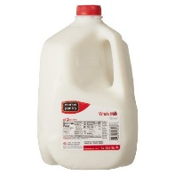
1 Cup = | 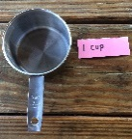
1 Tablespoon =  Tbsp | 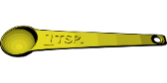
Spinosad
KEY

Monterey Garden
Insect Spray concentrate
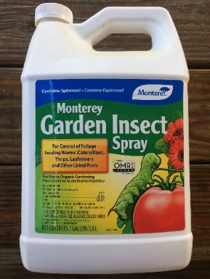

**Note: Sq. foot conversion to number of beds in the table below is approximate. The range of how much Spinosad to apply per sq. foot is wide and therefore extreme accuracy in space application isn’t crucial.**
Bed Size  150 sq ft  or  one 50 foot bed | Bed Size  300 sq feet or  one 100 foot bed | Bed Size  650 sq feet or  two 100 foot beds | Bed Size  1,000 sq feet or  three 100 foot beds | Bed Size  1,300sq ft  or  four 100 foot beds
How Much?  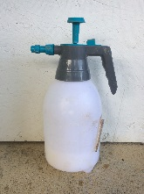  ½ gallon | How Much?  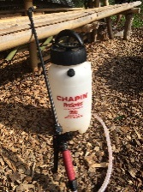  1 gallon | How Much?  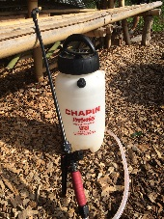  2 gallons | How Much?  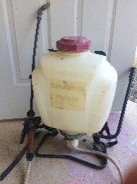  3 gallons | How Much?  4 gallons
Directions | Directions | Directions | Directions | Directions
2 Tablespoons of Spinosad | 4 Tablespoons of Spinosad | 8 Tablespoons of Spinosad | 12 Tablespoons  of Spinosad | 1 Cup  of Spinosad
Add  Water  ½ gallon | Add  Water  1 gallon | Add  Water  2 gallons | Add  Water  3 gallons | Add  Water  4 gallons
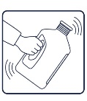  Mix | Mix | Mix | Mix | Mix
Spinosad
Monterey Garden Insect Spray concentrate

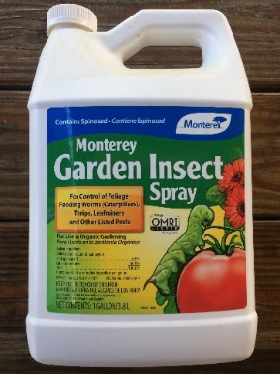
Directions

Spray tops and bottoms of leaves OR spray/soak ground around base of plant
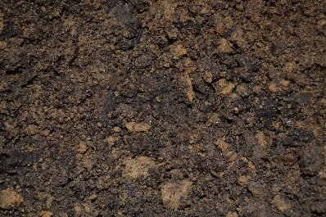
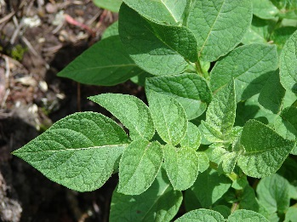

Only spray at Dawn or Dusk!

DO NOT spray while sunny or hot!

Information
- Hurts good bugs—use carefully and only as needed
- Derived through fermentation of a naturally occurring soil bacterium. Works fast! After ingesting Spinosad, insect pests die within 1 to 2 days.
- Will NOT persist in the environment

Pests
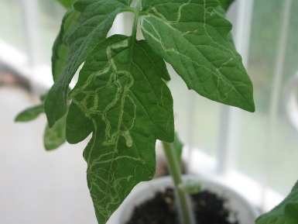
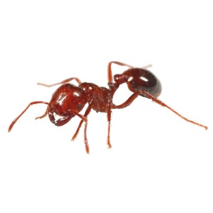
Potato beetle larve, thrips, leafminers, fire ants
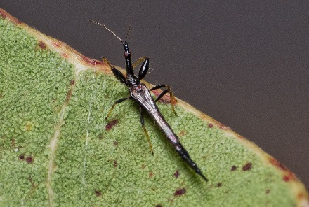
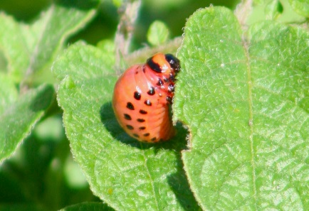

Where to Buy
Country Farm and Home
101 S Small Street, Pittsboro, NC 27312

Fifth Season
106 S Greensboro St Ste D, Carrboro, NC 27510

Internet

Cost
16 oz = $18.00
32 oz = $35.00
128 oz = $72.00

