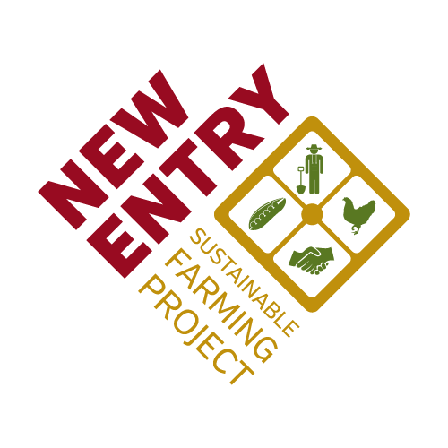  Community Food Systems Conference | Statement of intent  Exploring the intersection of food security, social justice, and sustainable agriculture.

Conference Fact Sheet
Title: Community Food Systems Conference
Date: December 5 – 7, 2017
Location: Boston Park Plaza, MA
Website: nesfp.org/community-food-systems-conference-2017

Conference Overview
This conference will address common underlying themes between food security, social justice and sustainable agriculture including obstacles in urban and rural environments and fostering community empowerment to create and sustain resilient local food systems. We will provide space for conversations around promoting, facilitating, and supporting self-reliance; breaking down barriers to racial justice; connecting communities to their food sources; and impacting communities at the local and regional level through sustainable food production. The conference will bring together leaders in, and advocates of, food security, sustainable agriculture and social justice movements to discuss their range of perspectives, how these areas overlap, and how to support one another’s work.

Attendees & Outreach
We expect 500 attendees from the fields of community food security, social justice and sustainable agriculture. Publicity materials will be distributed to our national network of community food systems organizations and by our national partners and leaders in the field.

Conference Highlights
- Workshops and networking sessions focused on food justice, policy, best practices, experiential education, sustainability, economic development, building community, and promoting access to healthy food in underserved communities. Exhibit hall for leading non-profit, academic, business and government organizations in the community food field.
- Meals featuring locally-grown foods including a reception at Boston Public Market.
- Field trips for an experiential component to see community food systems work in action.
- Keynote and plenary sessions on food security, social justice and sustainable agriculture.

Conference Sponsorship Opportunities
Our aim is to provide the maximum recognition and visibility possible commensurate with your gift. Sponsorship pledge timeline: 7/1/17 inclusion in printed conference materials.

Sponsorship Levels
Partner | Harvester | Cultivator | Sower | Seed
$15,000 | $10,000 | $5,000 | $2,500 | $1,500

Benefits by Sponsor Level:

Partner $15,000 (limited offer –1 only)
- Featured as Lead Sponsor of the Event
- Press release announcing sponsorship
- Prominent logo on all conference brochures and conference webpage
- Link to sponsor’s homepage on conference webpage
- Back cover full page advertisement in program booklet
- Verbal acknowledgement at main plenary of the conference
- Two complimentary Tables in Exhibit Hall (Prime Location)
- Four Conference passes and admission to conference reception at the Boston Public Market
- Further benefits and obligations are negotiable including category exclusivity

Harvester $10,000 (limited offer –2 only)
- Prominent logo on all conference brochures and conference webpage
- Link to sponsor’s homepage on conference webpage
- Half page advertisement in program booklet
- Verbal acknowledgement at main plenary of the conference
- One complimentary Table in Exhibit Hall (Prime Location)
- Three Conference passes and admission to conference reception at the Boston Public Market
- Further benefits and obligations are negotiable

Cultivator $5,000
- Logo on all conference brochures and conference webpage
- Link to sponsor’s homepage on conference webpage
- Quarter page advertisement in program booklet
- Verbal acknowledgement at main plenary of the conference
- One complimentary Table in Exhibit Hall
- Two Conference passes and admission to conference reception at the Boston Public Market

Sower $2,500
- Logo on all conference brochures and conference webpage
- Link to sponsor’s homepage on conference webpage
- Eighth page advertisement in program booklet
- Verbal acknowledgement at main plenary of the conference
- One complimentary Table in Exhibit Hall
- One Conference pass and admission to conference reception at the Boston Public Market

Seed $1,500
- Logo on all conference brochures, conference webpage, and in conference booklet
- Link to sponsor’s homepage on conference webpage
- One complimentary Table in Exhibit Hall
- One Conference pass and admission to conference reception at the Boston Public Market

Terms & Conditions
- Sponsors and Exhibitors are required to complete the attached form, or submit the form online here: https://www.tfaforms.com/4617282
  - Please refer to the form for payment instructions.
- Partner and Harvester sponsors: first-come first-served.
- All sponsorship pledges are due August 1, 2017 in order to be printed in the conference brochure. Final deadline for all sponsorship payments is October 1, 2017.
- Acceptance of sponsorship funding is at the sole & final discretion of New Entry Staff.
- Sponsors are responsible for providing color logo in electronic format by August 1, 2017. Please email to kristen.irvin@tufts.edu.
- Ad specs for booklet will be communicated in a follow-up email with additional information.
- Other gifts are welcome and will help to ensure affordability, accessibility and inclusivity for all interested conference goers.

We are open to alternative sponsorship including field trip, workshop track, reception, etc. Please contact Kristen Irvin for more information.

Exhibitor Tables Available
New Entry also invites your business to consider purchasing a 6ft table in our Exhibitor space at the Community Food Systems Conference.

Exhibitor Table Pricing: $500 - Regular | $250 - Nonprofits

- Exhibitors will receive a 6ft table in the Exhibitor Hall along with 50% off registration for one person to our full conference. (The exhibitor prices do not include meals, or admission to the conference reception at the Boston Public Market on Wednesday, December 6th.)
- The deadline to submit the Exhibitor form is September 1, 2017. Deadline for final payment is October 1st.

Please let us know if you have any questions. We thank you for your support!

For additional information, please contact:
Kristen Irvin
National Technical Assistance Coordinator
New Entry Sustainable Farming Project
kristen.irvin@tufts.edu / 978-349-2086
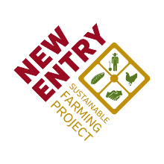

2017 Community Food Systems Conference Sponsor Form

Company/Organization Name:
Contact Person:
Contact Email:
Contact Phone:

Select Sponsorship Level:
 | Partner - $15,000 |  | Please enter the URL for your company's/organization's website. (This will be linked from our conference webpage.)
 | Harvester - $10,000
 | Cultivator - $5,000
 | Sower - $2,500
 | Seed - $1,500

Please indicate the name(s) and title(s) of your company's representatives who will be attending the conference as part of your sponsorship. If unsure at this time, New Entry staff will follow up with you closer to the event. (Partner Level - 4 passes; Harvester Level - 3 passes; Cultivator Level - 2 passes; Sower and Seed Levels - 1 pass)
Name | Title

Payment Option:
__ Request Invoice  Name/Department:  Email or mailing address: | __ Will mail a check  Please make payable to Third Sector New England, with “CFS Conference” in the memo line. Mail to:  New Entry Sustainable Farming Project  Attn: Mike Massicotte, Director of Finance and Administration  45 Merrimack Street, Suite 500  Lowell, MA 01852

Please sign to indicate that you accept the sponsor Terms & Conditions (above):
______________________________________________ _________________________
Name Date
Return this form via email to Kristen.irvin@tufts.edu or mail to
New Entry Sustainable Farming Project
45 Merrimack St., Suite 500
Lowell, MA 01852 Thank you for your support!

2017 Community Food Systems Conference Exhibitor Form

Company/Organization Name:
Contact Person:
Contact Email:
Contact Phone:

Select Sponsorship Level:
 | Regular ($500) |  | Please enter the URL for your company's/organization's website:
 | Non-profit ($250)

Payment Option:
__ Request Invoice  Name/Department:  Email or mailing address: | __ Will mail a check  Please make payable to Third Sector New England, with “CFS Conference” in the memo line. Mail to:  New Entry Sustainable Farming Project  Attn: Mike Massicotte, Director of Finance and Administration  45 Merrimack Street, Suite 500  Lowell, MA 01852

Please sign to indicate that you accept the Terms & Conditions (above):
______________________________________________ _________________________
Name Date
Return this form via email to Kristen.irvin@tufts.edu or mail to
New Entry Sustainable Farming Project
45 Merrimack St., Suite 500
Lowell, MA 01852 Thank you for your support!

